Internal verification of assessment decisions – BTEC Higher Nationals (RQF)

INTERNAL VERIFICATION – ASSESSMENT DECISIONS (Single Student)
Programme Title: |  | HND in Computing
Unit Number and Title: |  | Unit 17: Business Process Support
Assessor Name: |  | Ms. Chathurika Ratnayake |  | Internal Verifier Name: |  | Ms. Chathurika Ratnayake
Assignment title: |  | MediCare Pharmacy Chain (PVT) Ltd
Name of student | Submission Type  (First, Resubmission, Retake) | Grade the Assessor has awarded. | Assessment Decision Accurate (Y/N)  (Resubmission and retake must be capped at a Pass) | List the learning outcomes and grading criteria where inaccurate decisions have been made |  | State why the assessment decision is inaccurate.  *If an inaccurate decision is recorded the Internal Verifier must recommend actions detailing the issues to be addressed. The Assessor and the Internal Verifier must then confirm that the action has been undertaken before assessment decisions are issued to the student.
INTERNAL VERIFIER CHECKLIST |  |  |  |  |  |  | Y/N
Has the student and the Assessor confirmed the authenticity of the evidence?
Is there evidence of collusion or plagiarism? The work submitted for assessment has been carried out without assistance other than that which is acceptable according to the rules of the specification. The evidence submitted for this assignment is student’s own. The student has clearly referenced any sources and any artificial intelligence (AI) tools used in the work.
Is the assessor feedback to the student appropriate and constructive to each student? Provide comments below.
- Points out strengths and areas for improvement.
- Linked to relevant learning outcomes and assessment criteria.
- Clear as to why the student did not achieve higher grades.
- Identify opportunities for improved performance in future assignments.
GENERAL COMMENTS
Any actions required must be reviewed across the whole cohort.
Action Required |  |  |  |  | Target Date for Completion |  |  | Date Action Completed
I confirm that the assessment decisions are accurate, there is no evidence of assessment malpractice and any action points have been addressed and completed in respect of the whole cohort. I declare the work submitted for assessment has been carried out without assistance other than that which is acceptable according to the rules of the specification. The evidence submitted for this assignment is student’s own. The student has clearly referenced any sources and any artificial intelligence (AI) tools used in the work.
Internal Verifier signature |  |  |  |  | Date
Assessor signature |  |  |  |  | Date

Higher Nationals - Summative Assignment Feedback Form

Student Name/ID
Unit Title | Unit 17: Business Process Support
Assignment Number | MediCare Pharmacy Chain (PVT) Ltd | Assessor | Ms. Chathurika Ratnayake
Submission Date | 30th May 2026 | Date Received 1st submission
Re-submission Date |  | Date Received 2nd submission
Assessor Feedback:

*Please note that constructive and useful feedback should allow students to understand:

- Strengths of performance
- Limitations of performance
- Any improvements needed in future assessments

Feedback should be against the learning outcomes and assessment criteria to help students understand how these inform the process of judging the overall grade.

Feedback should give full guidance to the students on how they have met the learning outcomes and assessment criteria.
I certify that to the best of my knowledge the evidence submitted for this assignment is the student’s own. The student has clearly referenced any sources and any artificial intelligence (AI) tools used in the work. I have not solely used AI to grade the student’s work.

Grade: | Assessor Signature: |  | Date:
Resubmission Feedback:
*Please note resubmission feedback is focussed only on the resubmitted work
Grade: | Assessor Signature: |  | Date:
Internal Verifier’s Comments:
Signature & Date:

* Please note that grade decisions are provisional. They are only confirmed once internal and external moderation has taken place and grades decisions have been agreed at the assessment board.
Pearson Education 2016
Higher Education Qualifications
Internal Verification of Assignment Brief

Student Assessment Submission and Declaration
When submitting evidence for assessment, each student must sign a declaration confirming that the work is their own.
Student name: |  | Assessor name: Ms. Chathurika Ratnayake
Issue date: 19th March 2026 | Submission date: 30th May 2026 |  | Submitted on:
Programme: HND in Computing

Unit: Unit 17: Business Process Support
Assignment number and title: Assignment 01 MediCare Pharmacy Chain (PVT) Ltd

Plagiarism
Plagiarism is a particular form of cheating. Plagiarism must be avoided at all costs and students who break the rules, however innocently, may be penalised. It is your responsibility to ensure that you understand correct referencing practices. As a university level student, you are expected to use appropriate references throughout and keep carefully detailed notes of all your sources of materials for material you have used in your work, including any material downloaded from the Internet. Please consult the relevant unit lecturer or your course tutor if you need any further advice.

Student Declaration
Student declaration
I certify that the assignment submission is entirely my own work and I fully understand the consequences of plagiarism. I declare that the work submitted for assessment has been carried out without assistance other than that which is acceptable according to the rules of the specification. I certify I have clearly referenced any sources and any artificial intelligence (AI) tools used in the work. I understand that making a false declaration is a form of malpractice.

Student signature: Date:

General Guidelines

- A Cover page or title page – You should always attach a title page to your assignment. Use previous page as your cover sheet and make sure all the details are accurately filled.
- Attach this brief as the first section of your assignment.
- All the assignments should be prepared using a word processing software.
- All the assignments should be printed on A4 sized papers. Use single side printing.
- Allow 1” for top, bottom, right margins and 1.25” for the left margin of each page.

Word Processing Rules

- The font size should be 12 point, and should be in the style of Times New Roman.
- Use 1.5 line spacing. Left justify all paragraphs.
- Ensure that all the headings are consistent in terms of the font size and font style.
- Use footer function in the word processor to insert Your Name, Subject, Assignment No, and Page Number on each page. This is useful if individual sheets become detached for any reason.
- Use word processing application spell check and grammar check function to help editing your assignment.

Important Points

- It is strictly prohibited to use text boxes to add texts in the assignments, except for the compulsory information. eg: Figures, tables of comparison etc. Adding text boxes in the body except for the before mentioned compulsory information will result in rejection of your work.
- Avoid using page borders in your assignment body.
- Carefully check the hand in date and the instructions given in the assignment. Late submissions will not be accepted.
- Ensure that you give yourself enough time to complete the assignment by the due date.
- Excuses of any nature will not be accepted for failure to hand in the work on time.
- You must take responsibility for managing your own time effectively.
- If you are unable to hand in your assignment on time and have valid reasons such as illness, you may apply (in writing) for an extension.
- Failure to achieve at least PASS criteria will result in a REFERRAL grade.
- Non-submission of work without valid reasons will lead to an automatic RE FERRAL. You will then be asked to complete an alternative assignment.
- If you use other people’s work or ideas in your assignment, reference them properly using HARVARD referencing system to avoid plagiarism. You have to provide both in-text citation and a reference list.
- If you are proven to be guilty of plagiarism or any academic misconduct, your grade could be reduced to A REFERRAL or at worst you could be expelled from the course.

Submission Guidelines
- Start your answers from the end of the assignment brief. Do not use a new Word document.
- You must submit only two documents:
- Completed assignment in Word format.
- Turnitin similarity report in PDF format. (You may use any tool to check the similarity of your work.)
- File Renaming Format:
For the Assignment Word document:
- Format: Unit No_Unit Name_Assignment_Student ID_Student Name
- Example: Unit 17_Business Process Support_Assignment_02002000_M K C Perera
For the Turnitin PDF report:
- Format: Unit No_Unit Name_Turnitin Report_Student ID_Student Name
- Example: Unit 17_Business Process Support_Turnitin Report_02002000_M K C Perera
- Do not submit ZIP files.
- Late submissions will not be accepted for any reason.
- Submission deadlines will not be extended under any circumstances.
- Only LMS submissions are accepted. Submissions via WhatsApp, Email, or any other channel will not be accepted.
Please check your LMS access in advance.
- If you face any issues with the submission link or LMS, you must inform the Academic Admin Department at least 3 working days before the submission deadline.

Unit 17: Business Process Support
Assignment Brief
Programme Title | HND in Computing
Student Name/ID Number | Afry Nizam  1001953
Unit Number and Title | Unit 17: Business Process Support
Academic Year | 2026
Unit Tutor | Ms. Chathurika Ratnayake
Assignment Title | MediCare Pharmacy Chain (PVT) Ltd
Issue Date | 19th March 2026
Submission Date | 30th May 2026
Submission Format
The submission should be in the form of an individual report written in a concise, formal business style using single spacing and font size 12. You are required to make use of headings, paragraphs and subsections as appropriate, and all work must be supported with research and referenced using Harvard referencing system. Please also provide an end list of references using the Harvard referencing system.
The recommended word count is 5,000–5,500 words for the report excluding annexures, although you will not be penalised for exceeding the total word limit.
Unit Learning Outcomes
LO1 Discuss the use of data and information to support business processes and the value they have for an identified organisation

LO2 Discuss the implications of the use of data and information to support business processes in a real-world scenario

LO3 Explore the tools and technologies associated with data science and how it supports business processes

LO4 Demonstrate the use of data science techniques to make recommendations to support real-world business problems
Transferable skills and competencies developed
This assignment helps students develop several important transferable skills and competencies required in modern business environments. Students will enhance their analytical and critical thinking skills by examining how data and information support business processes and decision-making within an organization. The assignment also strengthens research and information-gathering abilities, as students must investigate data management practices, data science tools, and real-world business challenges. In addition, students will develop technical skills through the use of data analysis tools such as Python or Power BI, enabling them to interpret data and generate meaningful insights. Furthermore, the assignment improves problem-solving, communication, and report-writing skills, as students must design a data-driven solution, explain their findings clearly, and present justified recommendations to support business improvement. Overall, these competencies prepare students to effectively contribute to data-driven business environments.

Vocational scenario

MediCare Pharmacy Chain (PVT) Ltd

MediCare Pharmacy Chain (PVT) Ltd is a rapidly expanding healthcare retail company headquartered in Colombo. The company operates 15 pharmacy outlets across Sri Lanka and provides services such as prescription medicine sales, over-the-counter drugs, medical equipment, health supplements, and online pharmacy delivery services.

Currently, MediCare pharmacies manage their daily operations using separate manual systems and spreadsheets. Each branch records customer purchases, prescription details, medicine stock levels, supplier orders, and expiry dates using local Excel files. These files are later emailed to the head office for consolidation.

Due to the lack of a centralized digital system, the company experiences several operational issues such as:

- Delays in stock replenishment

- Difficulty tracking medicine expiry dates

- Errors in sales and prescription records

- Limited ability to analyze customer purchasing patterns

- Lack of real-time business insights for management decisions

To improve efficiency, MediCare plans to introduce a data-driven pharmacy management system that integrates sales data, inventory information, prescription records, and supplier details from all branches into a centralized database.

The company also intends to use data analytics and business intelligence tools such as Power BI and Python to analyze medicine demand, monitor inventory levels, and improve customer service.

You have been hired as a Junior Business Process Support Analyst to assist MediCare Pharmacy Chain in understanding how data and information can support business processes and improve organizational performance.

Assignment activity and guidance

Part 01

Prepare a report explaining how data and information support business processes within MediCare Pharmacy Chain.

Your report should include the following:
  - Explain how data and information are used in the business processes of MediCare Pharmacy Chain (e.g., sales processing, prescription management, inventory tracking).
  - Assess the importance and value of using data and information to improve the efficiency and accuracy of MediCare’s business operations.
  - Explain how different types of data are generated in MediCare Pharmacy Chain (for example: customer data, medicine sales data, prescription records, supplier information).
  - Describe tools and technologies used to collect, manage, and manipulate data to produce meaningful information that supports business operations.
  - Assess how data and information provide value to individual employees (pharmacists, managers, inventory staff) and the organization as a whole.
  - Evaluate the broader organizational impact of using data and information in MediCare’s business processes.

Part 02

Prepare a presentation slides discussing the implications of using data and information within MediCare Pharmacy Chain. The maximum number of presentation slides is 15. Please do not exceed this slide limit.

Your report should include:
  - Discuss the social, legal, and ethical implications of using data in business processes (such as handling sensitive patient or prescription information).
  - Describe common threats to organizational data, such as data breaches, unauthorized access, malware attacks, and data loss.
  - Explain mitigation techniques used to reduce these risks at both:
- Personal level (employees)
- Organizational level (system security, policies, backup strategies)
  - Analyse how the use of data and information affects real-world decision making and operational performance in MediCare Pharmacy Chain.

Part 03

Prepare a report discussing tools and technologies used in data science to support business processes.

Your report must include:
  - Explain different data science software tools and how they can support real-world business processes.
  - Explain different programming languages used in data science and how they can support MediCare Pharmacy Chain’s business operations.
  - Assess the benefits of using data science techniques to solve business problems.
  - Evaluate specific data science techniques (such as data visualization, predictive analysis, trend analysis, classification) and how they meet MediCare’s business requirements.

Part 04
Prepare a report explaining how data science can be applied to solve a business problem in MediCare Pharmacy Chain.
Your report should include:
  - Design a data science solution to address a business problem faced by MediCare Pharmacy Chain.
  - Implement a data science-based application based on your design using either:
- Python (using data science libraries such as Pandas, NumPy, Matplotlib)
OR
- Power BI using relevant DAX functions
Your report must include:
- Evidence of Python code segments or DAX queries used in the implementation
- Explanation of the purpose and process of each code segment or DAX query
  - Based on the results of your analysis, provide justified recommendations that MediCare Pharmacy Chain can implement to improve its business operations.
Recommended Resources

Please note that the resources listed are examples for you to use as a starting point in your research – the list is not definitive.
Textbooks
Boyer, J. (2010) Business Intelligence Strategy. MC Press (US). Jeston, J. and Nelis, J. (2018) Business Process Management. 4th edn. Routledge. Kolb, J. (2013) Business Intelligence in Plain Language: A practical guide to Data Mining and Business Analytics. CreateSpace Independent Publishing Platform. Marr, B. (2015) Big Data: Using SMART Big Data, Analytics and Metrics to Make Better Decisions and Improve Performance. 1st edn. John Wiley & Sons, Ltd. VanderPlas, J. (2016) Python Data Science Handbook: Tools and Techniques for Developers: Essential Tools for Working with Data. O’Reilly.

Journals
International Journal of Business Intelligence and Data Mining International Journal of Business Intelligence Research (IJBIR)

Web
gartner.com/en Research and Advisory (General Reference) datascience.codata.org Data science (Online data science journal)

Learning Outcomes and Assessment Criteria
 | Pass | Merit | Distinction
 | LO1 Discuss the use of data and information to support business processes and the value they have for an identified organisation |  | D1 Evaluate the wider implications of using data and information to support business processes in an identified organisation.
 | P1 Discuss how data and information support business processes and the value they have for organisations.  P2 Discuss how data is generated and the tools used to manipulate it to form meaningful data to support business operations. | M1 Assess the value of data and information to individuals and organisations in relation to real-world business processes
 | LO2 Discuss the implications of the use of data and information to support business processes in a realworld scenario
 | P3 Discuss the social legal and ethical implications of using data and information to support business processes.  P4 Describe common threats to data and how they can be mitigated at on a personal and organisational level. | M2 Analyse the impact of using data and information to support business realworld business processes.
LO3 Explore the tools and technologies associated with data science and how it supports business processes |  |  | D2 Evaluate the use of data science techniques against user and business requirements of an identified organisation
P5 Discuss how tools and technologies associated with data science are used to support business processes and inform decisions |  | M3 Assess the benefits of using data science to solve problems in real-world scenarios
LO4 Demonstrate the use of data science techniques to make recommendations to support real-world business problems
P6 Design a data science solution to support decision making related to a real-world problem.  P7 Implement a data science solution to support decision making related to a real-world problem |  | M4 Make justified recommendations that support decision making related to a real-world problem.

Higher Nationals – Grading Rubric

Grading Criteria | Achieved/Not Achieved | Comment
P1 Discuss how data and information support business processes and the value they have for organisations.
P2 Discuss how data is generated and the tools used to manipulate it to form meaningful data to support business operations.
M1 Assess the value of data and information to individuals and organisations in relation to real-world business processes
D1 Evaluate the wider implications of using data and information to support business processes in an identified organisation.
P3 Discuss the social legal and ethical implications of using data and information to support business processes.
P4 Describe common threats to data and how they can be mitigated at on a personal and organisational level.
M2 Analyse the impact of using data and information to support business real-world business processes.
P5 Discuss how tools and technologies associated with data science are used to support business processes and inform decisions
M3 Assess the benefits of using data science to solve problems in real-world scenarios
D2 Evaluate the use of data science techniques against user and business requirements of an identified organisation
P6 Design a data science solution to support decision making related to a real-world problem.
P7 Implement a data science solution to support decision making related to a real-world problem.
M4 Make justified recommendations that support decision making related to a real-world problem.

Afry Nizam
1001953
ANC
HND in Computing
BPS Assignment

Table of Contents
Introduction 19
Part 01 - How Data and Information Support Business Processes. 20
1.1 How Data and Information Used in Business Processes. 20
1.2 Importance and Value of using Data and Information. 20
1.3 Wider Implications of Data and Information 21
1.4 Types of Data Generated in MediCare Pharmacy Chain. 22
1.5 Tools and technologies used to manage data 22
1.6 Value of Data to the Employees and the Organization. 23
1.7 Wider Organizational Impact of using Data and Information. 24
Part 02 - Presentation on the Implications of Using Data and Information to Support Business Processes in MediCare Pharmacy Chain 25
Slide 2 - Introduction 25
Slide 3 - Social Implications 25
Slide 4 - Legal Implications 26
Slide 5 - Ethical Implications 26
Slide 6 - Common Data Threats 27
Slide 7 - Types of Common Data Threats 27
Slide 8 - Personal Security Measures 28
Slide 9 - Organizational Security Measures 28
Slide 10 - Backup and Recovery 29
Slide 11 - Data Supports Decision Making 29
Slide 12 - Operational Performance 30
Slide 13 - Wider Organizational Implications 30
Slide 14 - Conclusion 31
Part 03 - Tools and Technologies applied to Data Science to Support Business Processes. 32
3.1 Data Science Software Tools Supporting Business Processes 32
3.2 Data Science Programming Languages. 32
3.3 Advantages of Data Science Techniques to a Business Problem Solution. 33
3.4 Evaluation of Data Science Technologies Against MediCare Requirements. 34
Part 04 - Applying Data Science to Solve Business Problems in MediCare Pharmacy Chain 36
4.1 Design of a Data Science Solution 36
4.2 Implementation of Power BI Solution 37
Sales Analysis Dashboard 37
DAX Query 1 - Total Sales 38
Explanation 38
Inventory Monitoring Dashboard 38
DAX Query 2 - Low Stock Alert 39
Explanation 39
Expiry Date Monitoring Dashboard 39
DAX Query 3 - Expiring Medicines 40
Explanation 40
Prescription Monitoring Dashboard 40
DAX Query 4 - Total Prescriptions 41
Explanation 41
Data Visualization & Decision Making 41
Evaluation of Data Science Techniques Against Business Requirements 42
4.3 Recommendations for Improving Business Operations 42
Conclusion 43
References 45

Introduction
Data and data science technologies are crucial in today's organizations to support business processes, increase operational efficiency and support decision making. Data is used to record the activities of businesses, to enhance the services to the customers, to monitor the business, and to resolve business problems. Organizations can also use data science tools and business intelligence technologies to convert raw data into valuable information that aids in strategic planning and decision-making.
MediCare Pharmacy Chain (PVT) Ltd is a fast growing healthcare retail business with 15 retail Pharmacy outlets in Sri Lanka. The company offers a range of services including prescription medicine sales and over the counter drugs, medical equipment, health supplements and online pharmacy delivery services. At present, MediCare are manually handling their transactions at each branch and utilizing spreadsheets in Excel to track customer purchases, prescription information, stock and supplier details. These files are then forwarded to the head office by e-mail.
But individual manual systems have introduced some business issues including stock replenishment delays, inability to know when medicines expire, prescription data inaccuracies and restricted real-time business insights. To address these challenges, MediCare will be rolling out a centralized data-driven approach to managing pharmacies with the help of business intelligence and data science tools like Microsoft Power BI.
The assignment addresses the role of data and information in supporting the business processes in MediCare Pharmacy Chain, the social, legal and ethical issues regarding the use of data, and the role of data science tools and technologies in supporting the business processes. It also explores how Power BI dashboards and DAX formulas can be employed to address business challenges such as inventory management, medicine demand analysis, reporting delays, and operational decision-making. Lastly, the assignment assesses the role of data science in meeting MediCare's business and user needs, and enhancing the organization's performance and customer service.

Part 01 - How Data and Information Support Business Processes.

1.1 How Data and Information Used in Business Processes.
In MediCare Pharmacy Chain, data and information are used in most of the daily business processes. These processes help the company to control the operations and deliver improved services to the customer.
Sales processing is one of the key processes in business. Whenever the customers purchase the medicines, the cashier captures the information that includes medicine name, quantity, price and mode of payment. The information helps the company in following up sales on a daily basis and creating sales reports. Sales data also assists managers in knowing the frequency of sale of medicines and the less popular items (Marr, 2015).
Prescription management is another process that is important. Patient information, prescription by physicians and instructions on the medicine are registered by the pharmacists. The information is useful when pharmacists gives the right medication to the right patient. It also assists the company in keeping records that can be referred to in later days and patient safety (Jeston, J. Nelis, J., 2018).
Another business process that is important is inventory tracking. All the pharmacy branches have a record of the stocks, expiry dates, and suppliers. This will enable the company to know when the stock is low and when the medicines are expiring. Expired medicines can be sold without data and this can be dangerous to health.
Supplier management also involves the use of data. The records of suppliers like delivery dates, prices, and order quantities are taken. This helps MediCare in controlling the relationship with the suppliers and delivery of medicines in a timely manner.
Lastly, data and information are required in customer service. Purchase history of customers assists the company in knowing what the customers like and offer them personalized services. Finally, customers who constantly purchase specific medicines can be informed about the availability of stock.
Overall, data and information support all the key business processes in MediCare Pharmacy Chain and helps the company to run smoothly.

1.2 Importance and Value of using Data and Information.
The information and data are highly significant to improve efficiency and accuracy in the business operations of MediCare. The proper recording and analysis of data will help in minimizing errors and improve performance in a situation.
Better efficiency is one of the advantages. A centralized system will enable the staff to access information in a short time without having to go through various Excel files. This saves time and enables the employees to work more quickly (Marr, 2015).
The other significant advantage is accuracy. Manual systems are likely to cause human mistake like wrong recording of data or missing entries. With the use of digital systems, there is a reduced error in this and the correct information is stored. The proper data is particularly significant in the pharmacies where the wrong information about medicines may lead to severe issues.
There is also an enhancement of decision making with the aid of data. Report and data analysis allow managers to identify the trend of sales, demand, and stock requirements. This helps them to make knowledgeable choices regarding the placement of orders of medicines and inventory management.
Besides this, data improves customer satisfaction. Customers will be able to receive their medicines in time without any delays in case stock levels are managed correctly. This leads to customer loyalty and trust.
Therefore, data and information is very useful in improving efficiency, accuracy, decision making, and customer service in MediCare Pharmacy Chain.

1.3 Wider Implications of Data and Information
Not only efficiency and accuracy, but the centralized data-driven system adopted by MediCare has additional effects on the organisation and the healthcare industry in general. Real-time insights may be strategically beneficial to improve competitive advantage because they allow acting on the demand of the market and regulatory changes faster. By observing the laws of data protection like Sri Lanka related Personal Data Protection Act, patient confidentiality will be achieved and minimise chances of lawsuits. The benefits of Social prescription records are that they enhance patient safety and create trust in the citizen on the services of the MediCare. The economic aspect of data-driven forecasting saves wastages on the medicine that has expired and has lowered the operational costs and enhanced the sustainability. On an industry level, the digital transformation of MediCare creates the example of a digital transformation of other pharmacy chains, which promotes the shift to modernization in the sector. These extended implications are indicative that data is not simply operationally helpful but also of considerable importance in the long-term resilience and reputation.

1.4 Types of Data Generated in MediCare Pharmacy Chain.
The data that is produced by the MediCare Pharmacy Chain on daily operations is of different types. Such types of data will be useful in supporting different business processes.
Customer data is one of such types. This involves the name of customers, contact numbers, address, and purchase history. The data of customers can assist the company to offer improved services and keep in touch with the customers.
The other one is medicine sales information. It contains the information about the name of medicine, the amount sold, price and the date of sale. Sales information assists the management to determine the popular medicines and how to stock them in the future (Jeston, J. Nelis, J., 2018). Prescription data is also generated in MediCare pharmacies. This contains the information about patients, names of the doctors, prescription numbers, and instructions on the medicines. The data on prescription are highly valuable in ensuring safety in medication and record keeping.
Another type of data is inventory. This includes stock levels, expiry dates as well as reorder quantities. Inventory information helps the staff to control stock and prevent the lack of stock or expired medicines.
Lastly, supplier data will be created when medicines are ordered with suppliers. This will involve the supplier names, the quantity of order, the date of delivery and the payment details. Supplier data will enable MediCare to have a good relationship with suppliers and a good delivery time.
All these types of data are also necessary to support the day-to-day business activities of MediCare.

1.5 Tools and technologies used to manage data
Different tools and technologies are applied in gathering, processing and manipulation of data within MediCare Pharmacy Chain.
Microsoft Excel is one of the tools that are regularly used. Currently, MediCare branches are using Excel spreadsheets to document the sales, prescription and inventory. Excel is used to organize data in form of table and create basic reports.
Database management systems (DBMS) is another important technology. Centralized database system enables all the branches to store data at a central location. It is easier to access the information and minimize duplication (VanderPlas, 2016)
Another tool that is used in pharmacies is barcode scanners. There are Bar code scanners that read the medicine codes and automatically record the sales and stock information. This minimizes data entry processes that are manual and improves accuracy.
Pharmacy management systems refer to special software that is employed in controlling prescription, inventory and billing. These systems integrate several processes into one platform.
Such business intelligence tools as Power BI are used to analyze the data and generate visual reports. Such reports enable the managers to know the trends and make better decisions.
The data can also be stored on cloud storage technologies that will enable remote access and storage. The technologies make sure that the data is available at any times and places.
Overall, these tools and technologies can assist MediCare to convert raw data into meaningful information that supports business processes.

1.6 Value of Data to the Employees and the Organization.
Information is important to an individual worker and the organization in general.
For pharmacists, data used to ensure that the right medicines are given to the patients. The prescription records will enable the pharmacists to check on the details of the patients and prevent errors. This enhances safety of the patient and builds confidence.
For inventory staff, data can be used to track stock levels and expiry dates. Inventory information assists them in reordering medicines in good time as well as preventing shortage of stock.
To managers, data can give them important information on the sales performance as well as the behaviour of the customers. Data reports allow managers to determine the popularity of medicines and manage the level of stocks (Marr, 2015).
On the organization level, data can be used to enhance the overall efficiency and productivity. Data systems with a centralized nature enable information sharing among all departments easily. This saves time wastage and improves communication among branches.
Financial management also has data to support it. The sales information will be used to estimate the profits, costs, and the performance of the entire business.
Therefore, data provides value to the employees and the organization as it improves the accuracy, efficiency and decision making.

1.7 Wider Organizational Impact of using Data and Information.
The application of data and information extends to the success and growth of MediCare Pharmacy Chain in the long term.
Among the effects is the enhanced decision making. Through correct and real-time data, the management can make strategic decisions regarding business expansion, product choice, and pricing choices (Jeston, J. Nelis, J., 2018).
The other significant effect is the growth of the business. The analysis of data assists in identifying the demand and trends of customers. This will enable the MediCare to be able to expand services and introduce new products according to customer needs.
Customers are also satisfied with data. Customers feel more confident using the services of the company when they are provided with medicines on a regular basis and efficient services are offered.
Competitive advantage is also achieved by using the data. A company that utilizes data is able to react to changes in the market with speed than its competitors.
Moreover, information helps to achieve the culture of data in the organization. Employees will be more assured to use data to make more decisions and solve problems.
Altogether, the broader organizational effect of the data usage consists of the enhanced performance, customer satisfaction, and the eventual business success.
Besides positive effects in operations, there are also financial, technological and reputational implication involving the using of data in MediCare Pharmacy Chain. With the adoption of centralized data systems, initial investment cost can be increased because of the cost of installing a system, training of the staff, and servicing the new system. Nevertheless, in the long perspective, it can help the organization to achieve fewer operational mistakes and enhanced consumer satisfaction, as well as speedier service provision. In addition, proper data management enhances the reputation of MediCare, because clients have confidence with the organizations that secure sensitive prescription data. lastly, inadequate data handling could lead to legal actions, loss of money and chances of losing public confidence. Thus both the optimistic and pessimistic implications of data usage are positive and negative based on the level of control of the data systems.

Part 02 - Presentation on the Implications of Using Data and Information to Support Business Processes in MediCare Pharmacy Chain

Slide 2 - Introduction
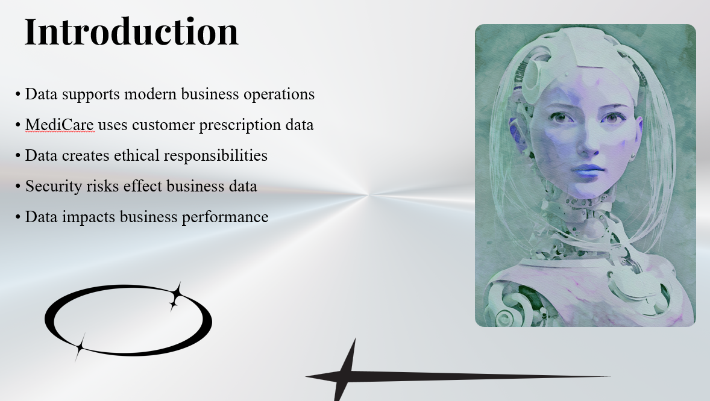
Figure 1 Introduction Slide
This slide sets the scene for the data and information is important in a business today and the key topics that will be covered in the presentation.

Slide 3 - Social Implications
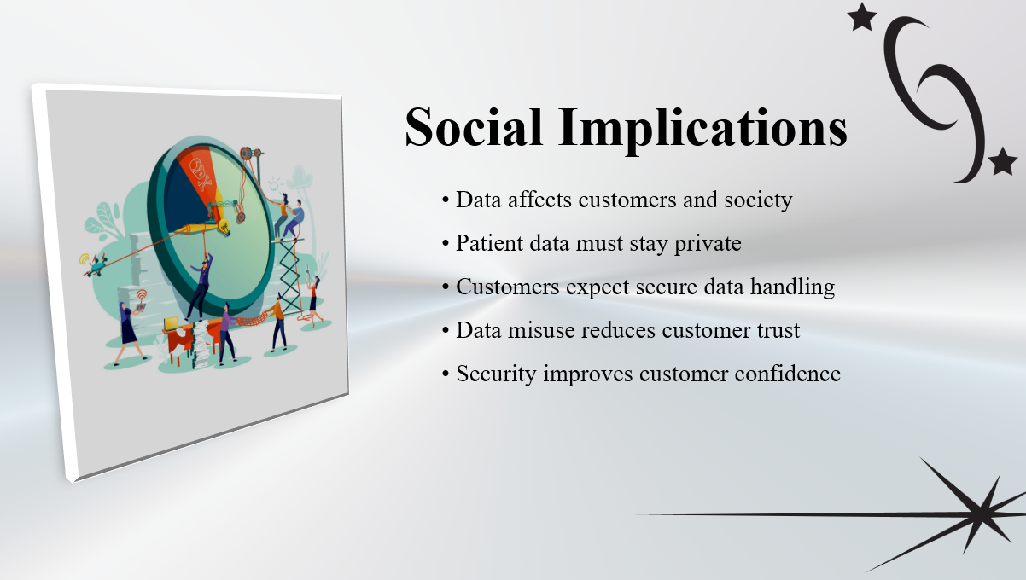
Figure 2 Social Implications Slide
This slide will outline the impact that customer trust, privacy, and secure treatment of patient information has with MediCare Pharmacy Chain and its customers.

Slide 4 - Legal Implications
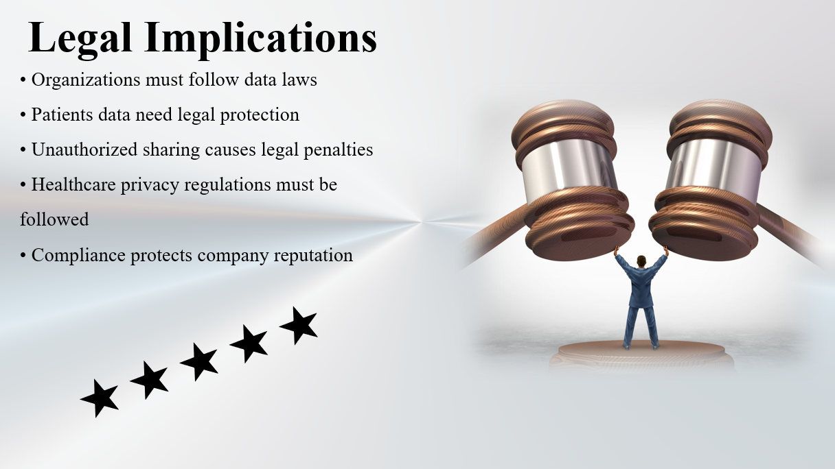
Figure 3 Legal Implications Slide
This slide covers the significance of adhering to data protection policies and regulations in the healthcare industry.

Slide 5 - Ethical Implications
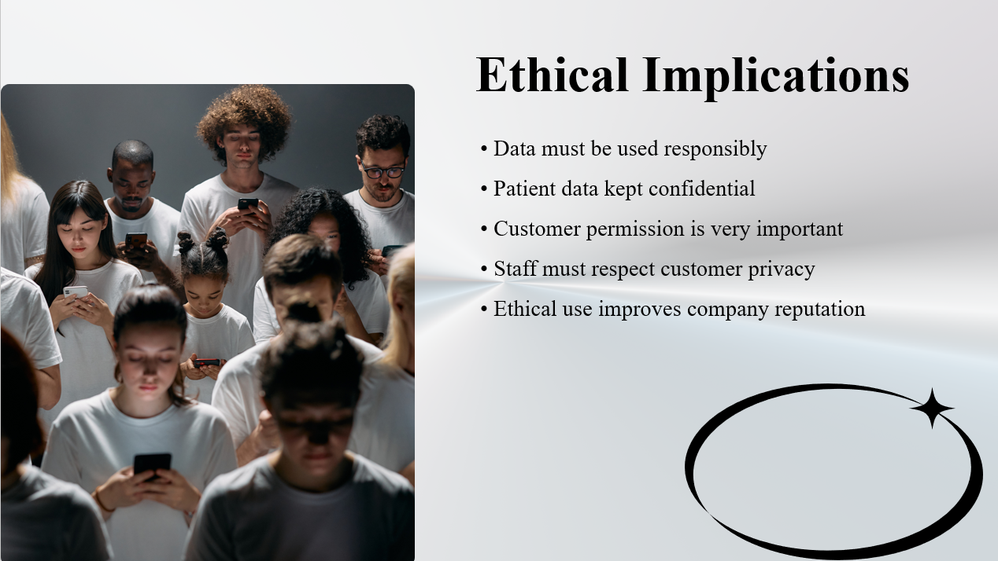
Figure 4 Ethical Implications Slide
This slide outlines ethical issues of customer privacy, confidentiality and responsible use of organizational information.

Slide 6 - Common Data Threats

Figure 5 Common Data Threats Slide
This slide explains some of the common threats to organizational data, including cyberattacks, system failures, and human errors.

Slide 7 - Types of Common Data Threats
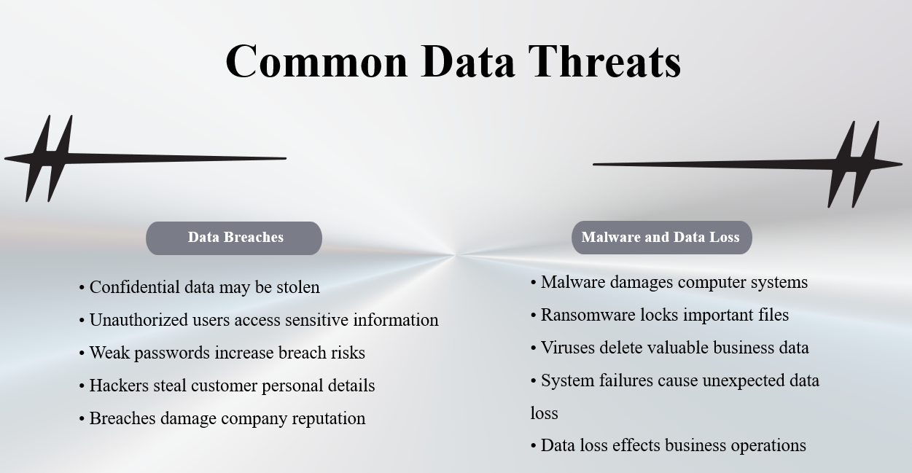
Figure 6 Types of Common Data Threats Slide
This slide outlines the potential for data breaches and reputation damage due to unauthorized access, and the use of weak passwords. In this slide, malware attacks, ransomware, viruses and the effects of data loss on business operation will be discussed.

Slide 8 - Personal Security Measures

Figure 7 Personal Security Measures Slide
This slide covers some of the best practices employees should have for being secure, including strong passwords, antivirus software and cybersecurity awareness.

Slide 9 - Organizational Security Measures

Figure 8 Organizational Security Measures Slide
In this slide, we will discuss the concept of organizational security measures such as firewalls, encryption, access control and backup systems.

Slide 10 - Backup and Recovery

Figure 9 Backup and Recovery Slide
This slide discusses how backup and recovery systems are used to protect important business data and ensure business continuity.

Slide 11 - Data Supports Decision Making
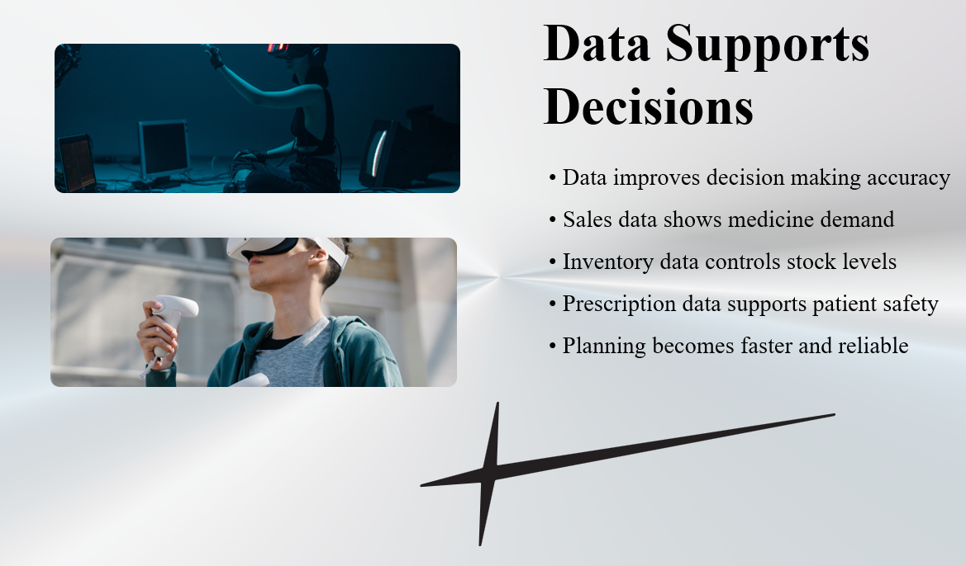
Figure 10 Data Supports Decision Making Slide
This slide describes the use of sales data, inventory data and prescription information to aid in management decision making in the MediCare Pharmacy Chain.

Slide 12 - Operational Performance
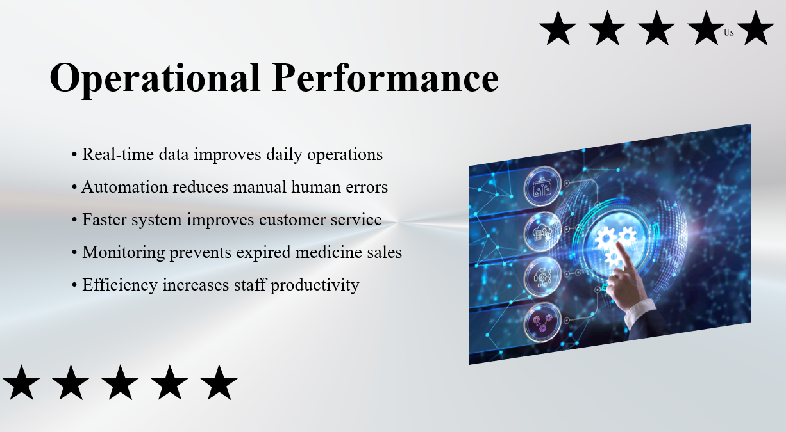
Figure 11 Operational Performance Slide
This slide examines the benefits of real-time data and automation for enhancing operational efficiency, productivity and customer service.

Slide 13 - Wider Organizational Implications
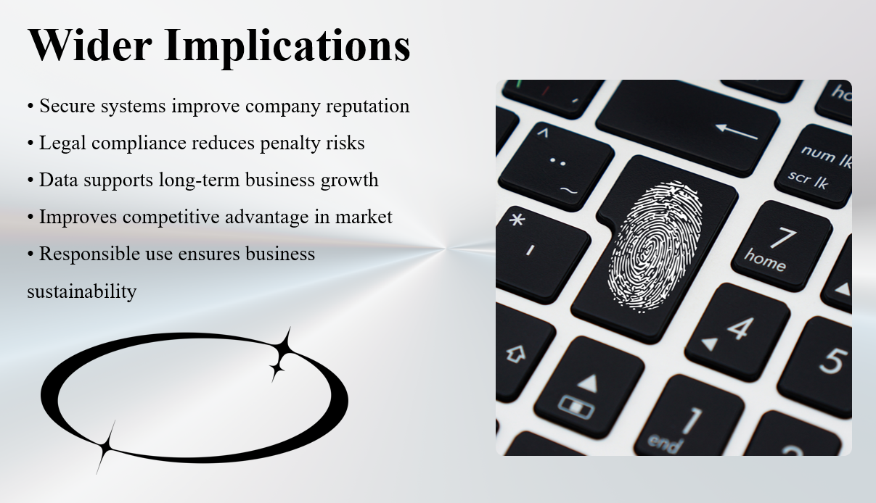
Figure 12 Wider Organizational Implications Slide
Provides information about the benefits of responsible use of data to company reputation, business growth, and competitive advantage.

Slide 14 - Conclusion
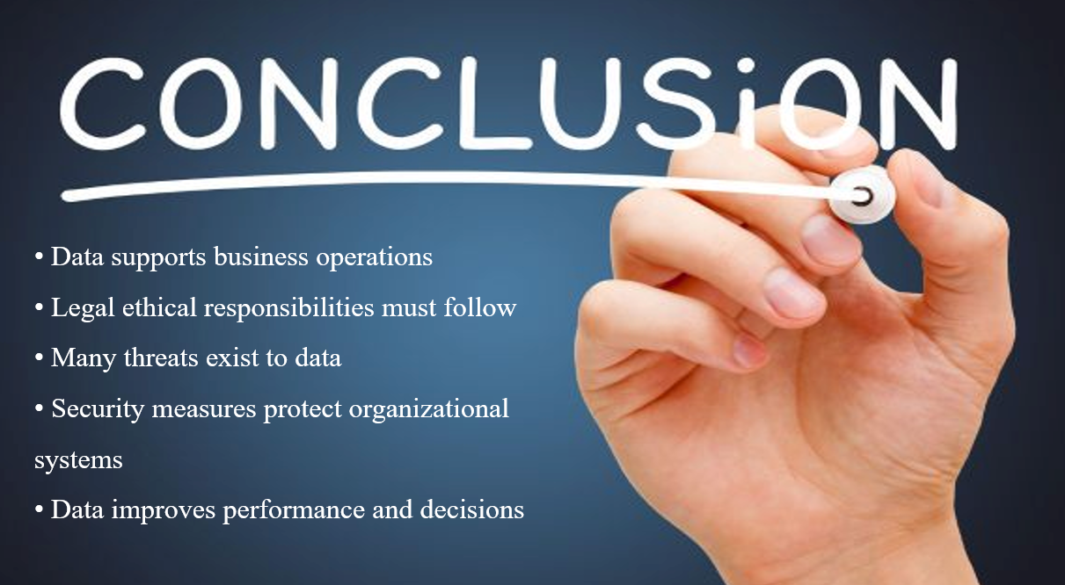
Figure 13 Conclusion Slide
This slide provides a summary of the importance of data, security, ethical responsibilities and business performance.

Figure 14 Thank You Slide

Part 03 - Tools and Technologies applied to Data Science to Support Business Processes.

3.1 Data Science Software Tools Supporting Business Processes
Data science software power tools are applied to gather, analyze and visualize data in the form of charts to back up business functions. The tools helps in making informed decisions and improving performance of organizations.
Microsoft Excel is one of the data science tools used commonly. Excel is widely used in data storage and organization data into table. Excel can be applied in MediCare Pharmacy Chain to record the sales of the medicines, prescription details and contact with suppliers. Other options offered by Excel are charts and formulas that allow sales trends to be analyzed and the inventory level should be monitored (Marr, 2015).
The other useful and important tool is the Power BI, business intelligence software that is applied in data visualization. Power BI enables one to make dashboards and reports using real-time data. Power BI will use in MediCare to show stock levels, demand of medicine, and sales performance in graphical form. This assists the managers in grasping the performance of businesses quickly and make more decisions.
Other data science tool is DataBase Management System (DBMS) including MySQL or SQL Server. Such systems contain huge volumes of data at a central place. A database system can be used by MediCare to store data about customers, prescription records, and suppliers of all branches. This ensures that there is less duplication and enhanced accuracy of data (Laudon, 2020).
Other helpful tool is Python-based analytics platforms. Python has libraries of data analysis like Segmented Numbers Pythons and Pandas. The tools are useful in the analysis of the large data and the identification of the trends in the data on sales and inventory.
Google cloud or Microsoft Azure are also cloud-based tools that can be used to store and process data. Cloud storage will enable MediCare to have access to data in different branches, and data protection.
Overall, data science software tools are beneficial to the business processes of MediCare by enhance the process of data storage, analysis, and visualization.

3.2 Data Science Programming Languages.
Programming languages are also significant in data science since they enable companies to compute and realize huge volumes of information.
Python is one of the most popular programming languages, which is applied in data science. Python is also very popular due to its simplicity with great power. Python has other libraries like Pandas, Matplotlib and Scikit-learn (VanderPlas, 2016).
R is also another significant programming language; R is used for statistical analysis and data visualization. It assists companies in doing highly complicated calculations and creating in-depth reports. MediCare service using R is capable of examining the purchasing behavior of customers and discovering seasonal needs of medicine.
The other language regularly used in data science is SQL (Structured Query Language). The SQL is used to manage and read the data on databases. SQL can allow MediCare to search specific medicine records, stock levels and be able to produce inventory reports.
The use of Java and C# is also in business systems development. These programming languages are useful in the development of pharmacy management system and intergrte databases with user interface.
The programming languages will enable MediCare to handle the data processing process manually and to eliminate manual work and boost the efficiency of operational processes.

3.3 Advantages of Data Science Techniques to a Business Problem Solution.
The data science is widely applicable in business problem resolutions with numerous benefits in the real world.
Improved decision making is one of the advantages. Through data science, organizations will be able to study a large amount of data and see patterns that can be of any use. As an illustration, the MediCare managers can be able to examine sales data to establish the medicines that are in high demand. This will help them in better decisions regarding the orderings of stocks (Marr, 2015).
Increased efficiency is also another advantage. Online data processing will save time and human input in the form of data entry and making reports. This saves time and it minimizes errors that are used in day-to-day processes.
The data science also helps in minimizing costs. Through inventory data, MediCare will prevent excessive stock and expired drugs by analyzing them. This helps in minimizing the financial losses and increases the profitability.
The other advantage is on improved customer service. Data science is useful in analyzing the customer behaviour and preferences. MediCare will be in a position to prescribe medicines and offer personalized services with the help of this information.
Risk management is also enhanced by the way of data science. The problems that may be faced like a shortage of stock or supply delays may be predicted before they occur. This enables the organization to take the preventive measures.
Overall, data science methods assist MediCare in resolving the business issues in terms of efficiency, cost reduction, and decision making.

3.4 Evaluation of Data Science Technologies Against MediCare Requirements.
MediCare Pharmacy Chain can fulfill its business needs with the application of different data science techniques. Such methods contribute to the solutions of particular problems and better performance of the business.
One of such method is Power BI data visualization. The concept of data visualization is represented as a display of data in the form of charts, graphs, and dashboards. Power BI dashboards are capable of demonstrating the level of stock, the promotional trends and the expiry date. This method will satisfy the needs of MediCare that have real-time insights into the business and helps managers in seeing the information rapidly (Laudon, 2020).
Predictive analysis is also another technique that is important. The predictive analysis is a technique that is based on past records to forecast the future. The mediCare will be able to predict future medicine demand using the past sales data with the help of predictive models. This will assist in minimizing the shortages of stocks and a constant supply of medicines.
The other beneficial method is trend analysis. The trend analysis identifies the patterns of time. As an illustration, MediCare will be in a position to examine monthly sales records and realize seasonality of demand of medicines like flu pills. This will help the managers in planning inventory to prevent the shortage of the inventory.
Another method of data science is classification that is applied to data grouping some data into categories. MediCare will be able to categorize the medicines according to expiry dates, level of demand, or type of medicine. This assists in placing more priorotize on stock management and minimizing the expired medicines.
Comparing these techniques with the business needs of MediCare, one should admit that each technique is associated with certain advantages. The concept of Power BI enhances the knowledge about business performance. Predictive analysis will also aid in predicting the demand and avoiding shortage of stock. Long-term planning is the trend analysis. This helps in the management of inventory and optimization of risks.
Thus, the operational requirements of MediCare are supported directly by the use of these methods of data science and promotes better business performance.

Technique | Meets Business Need | Limitation
Data Visualization | Shows real-time stock levels | Needs updated data
Predictive Analysis | Forecasts medicine demand | Requires historical data
Trend Analysis | Identifies seasonal demand | Slower for real-time decisions
Classification | Organizes medicines by category | Requires accurate labels

Table 1: Comparison of Techniques
Comparing these techniques with business needs of MediCare, the predictive analysis technique seems to be useful tool since it would directly help with inventory planning and helping to prevent stock shortages. Nonetheless, the importance of data visualization is similar since the managers can track the performance in real-time. The classification techniques are good in the organization of medicines but they require the input of correct data. Therefore, a predictive analysis/visualization using Power BI solution is the most suitable to provide operational and decision-making needs of MediCare.

Part 04 - Applying Data Science to Solve Business Problems in MediCare Pharmacy Chain

4.1 Design of a Data Science Solution
Poor inventory management is one of the major business issues at hand in MediCare Pharmacy chain due to the use of separate Excel spreadsheets at various branches. As there is no central system, managers cannot keep track of the stock at any given time. This results in medicines not being available on schedule, restocking issues, medicines expiring, and lower customer satisfaction.
The solution to this problem is to have a central data science solution with a centralized database, integrated with Power BI dashboards. The solution will gather and analyze every data that is collected from all the pharmacy branches and give the managers and employees real-time information regarding the business.
The solution proposed will primarily be based on:
- Ensuring the availability of medicines,
- Identifying low-stock medicines
- Tracking medicine expiry dates
- Examining the sales of medicines.
- Monitoring branch performance
- Supporting management decision-making
The system will rely on data gathered from sales, inventory, prescription information, and supplier data. All this information will be stored in a centralized database that will be linked to Power BI for analysis and visualization.
The solution design comprises several phases. Data collection is the first step. All pharmacies will be integrated with the central pharmacy information system. Afterwards, comes the second stage, data cleaning and preparation. To enhance data quality, incorrect or duplicate records will be removed. The third stage is to analyze and visualize data in Power BI dashboards. Finally, managers will be able to track operations and make decisions on these dashboards.
The Power BI solution offers a number of benefits to MediCare Pharmacy Chain. Managers will have immediate access to information, can easily see levels of stock, can see trends in businesses and can decrease delays in operations. In addition, this solution enhances the communication between the branches and head office as it allows the storage of all data in a single system.
The solution meets the business needs by providing accurate stocking information, quick reporting and better decision making, which is required by MediCare. It also addresses user needs - the dashboards are straightforward, visual, and simple to interpret by employees and managers (Marr, 2015).

4.2 Implementation of Power BI Solution
Microsoft Power BI was used to implement the proposed data science solution. Power BI is a business intelligence solution for analyzing data, building dashboards and producing visual reports. It is useful to companies for turning raw data into valuable business information (Laudon, 2020).
MediCare Pharmacy Chain's dashboards were created with medicine sales information, inventory information, supplier information, and prescription information. The dashboards enable managers to track the performance of the pharmacy and make better decisions.
There are several dashboards and DAX functions implemented in the Power BI implementation.
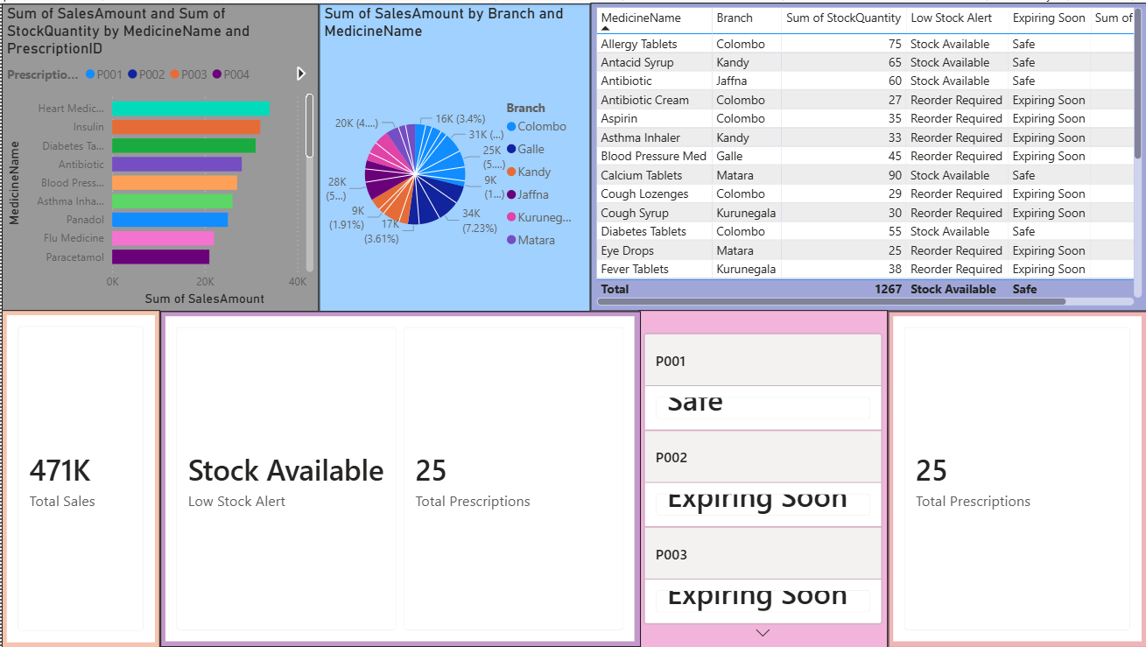
Figure 15: MediCare Power BI Dashboard

Sales Analysis Dashboard
The Sales Analysis Dashboard allows MediCare to track each branch's medicine sales. The dashboard displays:
- Total sales revenue
- Top-selling medicines
- Monthly sales trends
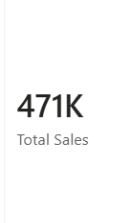
Figure 16 Sales Analysis Dashboard
This dashboard will help the manager know which medicines are in high demand and which branches are the best.

DAX Query 1 - Total Sales
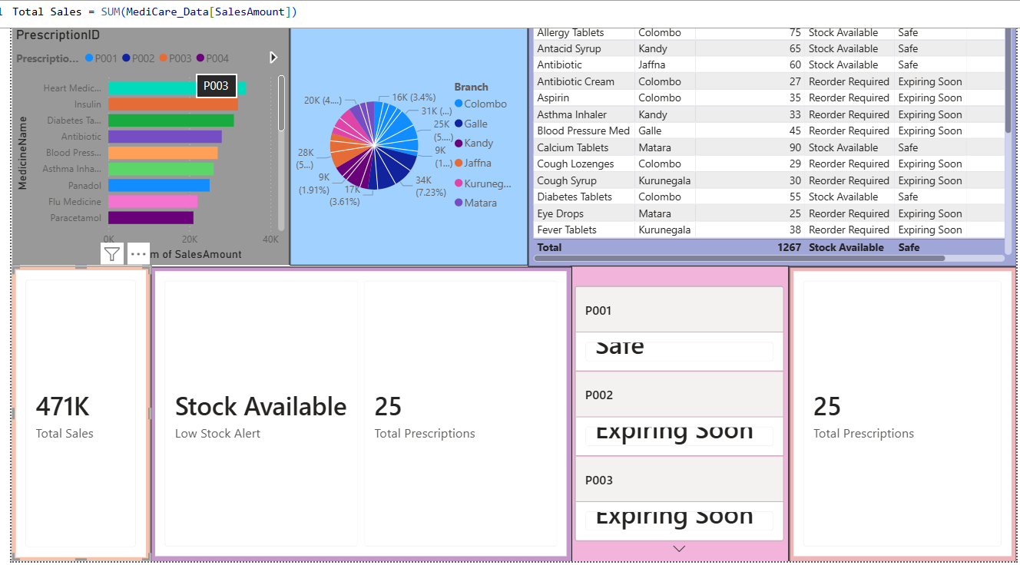
Figure 17: Power BI Total Sales Equation

Explanation
This DAX function returns the sum of all the pharmacy branches revenue from sales. The SUM function is used to sum all the values in the “TotalAmount” column of the sales table.
The intent of this query is to be used as a way to track overall business performance and sales trends. When sales rise or fall, management can explore the reasons for the sales rise or fall and can make business decisions based on that.

Inventory Monitoring Dashboard
The Inventory Monitoring Dashboard aids in managing medicines stock levels and preventing shortages for MediCare. The dashboard displays:
- Current stock quantity
- Low-stock medicines
- Reorder alerts
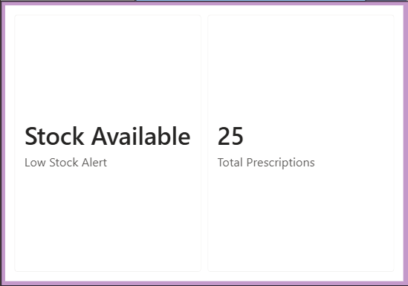
Figure 18 Inventory Monitoring Dashboard
This dashboard enhances inventory management and the risk of medicine shortage is minimised.

DAX Query 2 - Low Stock Alert
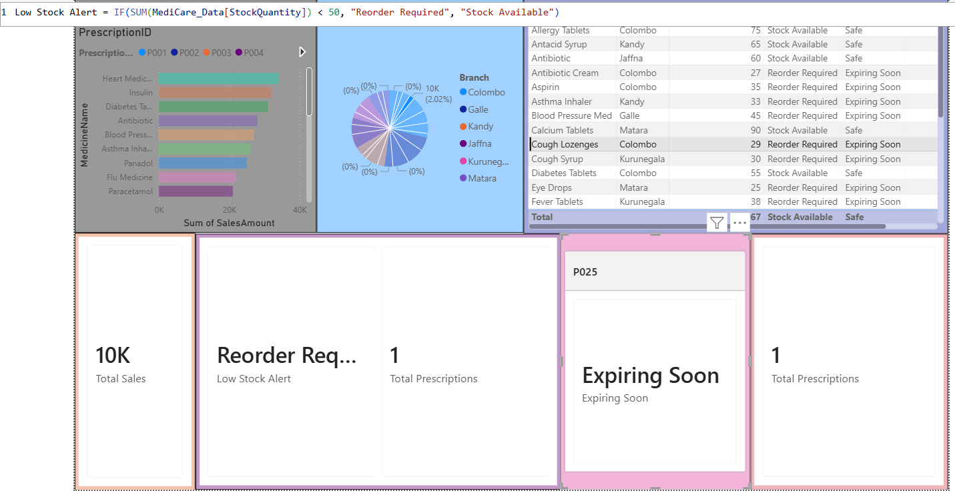
Figure 19: Power BI Low Stock Equation

Explanation
This DAX function is used to compare the Stock Quantity to less than 50 units. The system will show “Reorder Required” if stock is low. If not, it will show “Stock Available.”
This query is used to identify medicines to be replenished in advance of possible shortages. This helps customers get medicines in time when they need them, hence enhancing customer satisfaction.

Expiry Date Monitoring Dashboard
The expiry tracking of medicines is an essential function in a pharmacy as the medicines that have expired may pose a health threat to customers. The Expiry Monitoring Dashboard assists staff to identify medicines that are approaching the expiry date.
The dashboard displays:
- Medicines which are within 30 days of the expiration date.
- Expiry trends by branch
- Expired stock quantity

Figure 20 Expiry Date Monitoring Dashboard

DAX Query 3 - Expiring Medicines
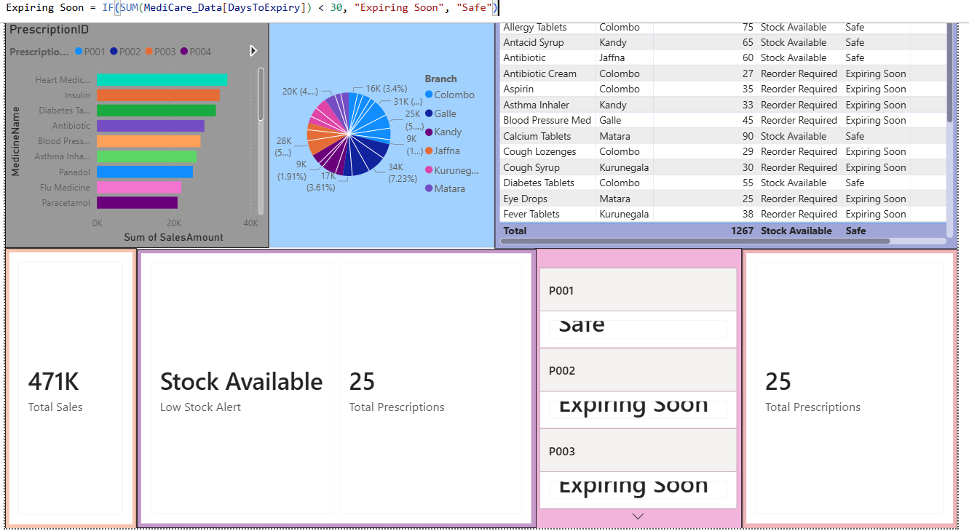
Figure 21: Power BI Expiring Medicines Equation

Explanation
This DAX function will verify the number of days until a medicine's expiration date. If the value is less than 30 days, the medicine is indicated as “Expiring Soon”.
This is a query to minimize financial losses and patient safety, and ensure medicines are removed or replaced before they expire.

Prescription Monitoring Dashboard
The Prescription Dashboard is a tool that enables MediCare to track or monitor prescriptions and pharmacy operations. It displays:
- Total prescriptions processed
- Most prescribed medicines
- Prescription trends
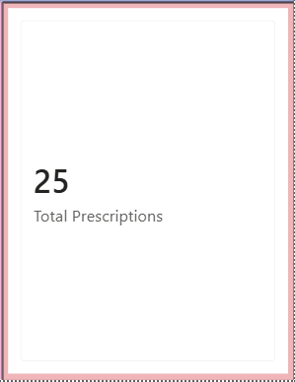
Figure 22 Prescription Monitoring Dashboard

DAX Query 4 - Total Prescriptions
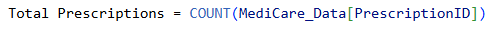
Figure 23: Power BI Total Prescriptions Equation

Explanation
In this DAX function, we are counting down all the prescriptions filled by all the MediCare pharmacies.
This query will assist managers in gaining insight into customer needs and prescriptions. This information is used for inventory planning and buying of medicines.

Data Visualization & Decision Making
Power BI dashboards provide a visual way to represent business data in charts, graphs and visual indicators. The visual report is used to communicate complicated information in a concise manner to managers and help them to make better decisions.
If a medicine is constantly in short supply, for instance, managers can raise reorder amounts, etc. In the same way, if sales information indicates that a medicine is not being desired, managers can decrease future purchases to lessen the amount of wastage.
The use of data visualization also enhances communications among the branches and management as everyone can see the same information at the same time (VanderPlas, 2016).

Evaluation of Data Science Techniques Against Business Requirements
Data science techniques in MediCare Pharmacy Chain should satisfy the business and user needs. The organization needs to have an accurate inventory tracking along with real time reporting, medicine demand analysis and better decision making.
These business needs are well met by dashboards in Power BI, which offer visual reports and real-time monitoring. The managers can easily spot medicines with low stocks, gain insight into sales performance and check expiry dates. This will increase operational efficiency and minimise manual reporting delays.
Also, automated analysis is possible with DAX functions. In particular, the low stock alert system will automatically recognise medicines that need re-ordering when they fall below a specified threshold. This helps to avoid stock-outs and enhances customer satisfaction.
The dashboards are easy to understand from the users point of view as they are provided with charts, tables and visual indicators. The data can be retrieved quickly by pharmacists, inventory personnel, and managers without having to possess advanced technical skills.
But, there are also some limitations to the solution. Power BI relies on data being entered accurately, so inaccurate or incomplete data can lead to inaccurate reports. Staff also need to be trained on how to effectively use dashboards. The organization is also responsible for system maintenance and cyber security measures to ensure that the confidentiality of sensitive data from the pharmacies is maintained.
In conclusion, the overall assessment indicates that Power BI is an excellent tool for MediCare Pharmacy Chain, as it aligns well with their operational needs, reporting needs, and decision-making processes.

4.3 Recommendations for Improving Business Operations
From the analysis performed with the Power BI solution, a number of recommendations can be made to enhance MediCare Pharmacy Chain's business operations.
The first step is to automate the alerts for inventory to all branches. Low stock reminders help staff in inventory to be ready to place orders for medicines before shortages. This recommendation is suitable as it helps to enhance the availability of medicines and enhances customer satisfaction.
The second is to regularly use expiry monitoring dashboards. The medicines that are near their expiration dates should be removed from storage at an early stage. This helps to minimise financial loss and patient safety.
The third suggestion is to have real-time, central reporting of all branches. Sales and inventory information should be tracked on Power BI dashboards rather than in manual Excel reports. This recommendation helps in achieving operational efficiency and avoids reporting delays.
We also recommend training employee on Power BI and data management. Employees need to know how to use dashboards appropriately and how to read and understand business reports. It is crucial since trained staff members can better make operational decisions and avoid reporting errors.
MediCare should also be more stringent with its cybersecurity protocols to ensure that the information it has on its patients is not sensitive and not exposed to unauthorized use. The organization should employ robust passwords, secure login procedures and frequent data backups. The recommendation is based on the fact that the data in a pharmacy is confidential and cannot be exposed to cyber threats.
Lastly, there is a need to further employ data analytics methods like trend analysis and predictive analysis for forecasting medicine demands and better inventory planning in MediCare. This lowers waste and aids in the longer-term development of business (Marr, 2015).

Conclusion
Finally, it is noted that data, information and data science technologies are crucial to the support of business processes and organisational performance in MediCare Pharmacy Chain. In business many tasks are carried out with the use of data, including handling sales, handling prescriptions, tracking inventory, handling of suppliers and customer service. Centralized systems and business intelligence technology can enhance efficiency, accuracy, reporting and decision making.
The issues discussed in this assignment were the significance of data in business operations, social, legal and ethical issues related to the use of organizational information and common threats that may be encountered by business information systems. It also introduced value of using tools and technology like Excel, database system, cloud platforms and Microsoft Power Bi to support business processes and enhance operational performance.
In addition, the assignment illustrated the use of Power BI dashboards and DAX function to address business challenges in MediCare Pharmacy Chain. The proposed solution aims to keep track of medicines sold, monitor stock levels, identify medicines that are low in stock, monitor the expiry dates, and make better management decisions with real-time reporting and visualization of medicines.
The suggestions given in this assignment such as automated alerts for inventory, central reporting, employee training and enhanced cybersecurity can aid in the enhanced operational effectiveness, minimized business risks, and boosted client satisfaction for the MediCare organization. While accurate data, employee training, and proper system management are crucial to the success of this implementation, the adoption of data science and business intelligence technologies will enable MediCare Pharmacy Chain to be one of the most efficient, secure, competitive, and data-driven healthcare organizations of the future.

References

- Chaffey, D. and White, G. (2011) Business Information Management: Improving Performance Using Information Systems. 2nd edn. Harlow: Pearson.
- Few, S. (2013) Information Dashboard Design: Displaying Data for At-a-Glance Monitoring. 2nd edn. Burlingame: Analytics Press.
- Han, J., Kamber, M. and Pei, J. (2012) Data Mining: Concepts and Techniques. 3rd edn. Waltham: Morgan Kaufmann.
- O’Brien, J.A. and Marakas, G.M. (2011) Management Information Systems. 10th edn. New York: McGraw-Hill.
- Rainer, R.K. and Prince, B. (2021) Introduction to Information Systems. 9th edn. Hoboken: Wiley.
- Sharda, R., Delen, D. and Turban, E. (2019) Business Intelligence, Analytics, and Data Science: A Managerial Perspective. 4th edn. Harlow: Pearson.
- Stair, R. and Reynolds, G. (2018) Principles of Information Systems. 13th edn. Boston: Cengage Learning.
- Whitman, M.E. and Mattord, H.J. (2018) Principles of Information Security. 6th edn. Boston: Cengage Learning.

